MPT Myanmar National League 2018
Photo

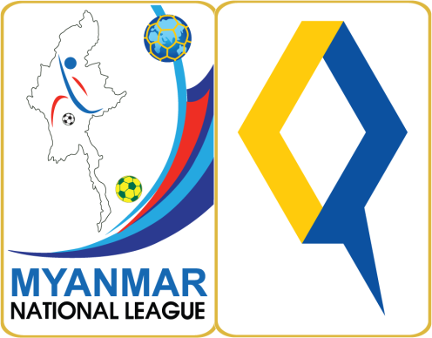

Media Accreditation Form

Name
Media Organization
NRC/PP No.
Address
Phone No.
Email Address
Designation

Check Type Of Media
 | Daily Newspaper |  | Weekly Journal
 | TV |  | FM Radio
 | Magazine |  | Online Media
 | Photographer |  | Freelance

Chief Editor’s Signature and Stamp
Name
Position
Signature and
Stamp

NOTE: If you are applying as a freelance photographer or Journalist, you will need to accompany this form with a signed letter from the editor of the organization you are on assignment for.

Please submit this form no later than Sunday,
31 December 2017.

Email – mnlofficials@gmail.com
Further Information :
Mr. Ye Min Win
MNL Media Department
Ph: +959 972704151

